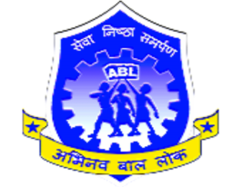
ABHINAV BAL LOK (Regd.)
Photo of the
Social Worker
Website: www.abhinavballokngo.org E-mail: abhinavballok1968@gmail.com Serving the Nation Legacy of Trust Since 1968
Approved NGO by Government of National Capital Territory of Delhi
(Registration No. 3904{1968-69} Under the Society Registration Act XXI of 1860)
Non-Aided.Unique ID of NGO: DL/2017/0158115 Under NITI AYOG(NGO DARPAN)
Project Reviewed by DGET Ministry of Labour. Government of India 1990.
Corporate Office: Z-1/501, TDI Kingsbury, Kundli, Haryana-131028
Voc-Varsity Website Link : http://www.vishwakarmavoc-varsity.com/project-details?id=4
LIFETIME MEMBERSHIP FORM
For Social Work Honorary Services
Name of Social Worker Mr./Mrs/Miss/Ms. ______________________________________________
Date of Birth_________________________Mob.No._______________________________________
Other Media Contact________________________________________________________________
Address___________________________________________________________________________
__________________________________________________________________________________
Credentials/ Education/ Position/ Profession/ Skills/ Associated Organizations/ Family/Experience
_________________________________________________________________________________
_________________________________________________________________________________
_________________________________________________________________________________
____________________________________________________________________________________________________________________________________________________________________
Enclosures
1. ID 2.PAN 3.Supporting Documents( ) Lifetime Membership Fee Rs.250/-/ Donation

Applicant Signature
ABL MEMBERSHIP NO. ISSUED
BY THE CORPORATE OFFICE

________________________________________

